[**Back to HCI Lab Home Page**](http://iitg.vlab.co.in/?sub=72&brch=170)

**GOMS Model**

**GOMS (G**oals, **O**perators, **M**ethods, and **S**election rules**)** is predictive model of human information processing used for task analysis in human computer interaction design. The model was proposed by Stuart Card, Thomas P. Moran and Allen Newell in 1983. The model is used to analyze user’s physical , cognitive and perceptual interactions with computer while achieving a task or a goal in best possible way.

**Goals** are what users intend to do. **Operators** are actions they perform to achieve their goals. **Methods** are operator sequences that accomplish a goal. Multiple methods can exist to accomplish same goal. **Selection rules** describe when a user will select a method over the other.

In Key Stroke Level (KLM) GOMS model the physical, cognitive and perceptual actions during a task is decomposed in form of fundamental keystroke sequence. The model specifies time required for each fundamental keystroke. Thus we can predict the total time of completing a task. Multiple methods can be compared based on the total time to complete a task in order to determine which is the most efficient method for accomplishing the task is.

Following  example of  basic  GOMS  model is taken from **John & Kieras (1996b).** It models the task of moving text in a word processor, in the context of editing a manuscript. Note the use of sub goals and selection rules, which do not exist in KLM.

GOAL: EDIT-MANUSCRIPT

. GOAL: EDIT-UNIT-TASK ... repeat until no more unit tasks

. . GOAL: ACQUIRE UNIT-TASK

. . . GOAL: GET-NEXT-PAGE ... if at end of manuscript page

. . . GOAL: GET-FROM-MANUSCRIPT

. . GOAL: EXECUTE-UNIT-TASK ... if a unit task was found

. . . GOAL: MODIFY-TEXT

. . . . [select: GOAL: MOVE-TEXT* ...if text is to be moved

. . . . GOAL: DELETE-PHRASE ...if a phrase is to be deleted

. . . . GOAL: INSERT-WORD] ... if a word is to be inserted

. . . . VERIFY-EDIT

*Expansion of MOVE-TEXT goal

GOAL: MOVE-TEXT

. GOAL: CUT-TEXT

. . GOAL: HIGHLIGHT-TEXT

. . . [select**: GOAL: HIGHLIGHT-WORD

. . . . MOVE-CURSOR-TO-WORD

. . . . DOUBLE-CLICK-MOUSE-BUTTON

. . . . VERIFY-HIGHLIGHT

. . . GOAL: HIGHLIGHT-ARBITRARY-TEXT

. . . . MOVE-CURSOR-TO-BEGINNING 1.10

. . . . CLICK-MOUSE-BUTTON 0.20

. . . . MOVE-CURSOR-TO-END 1.10

. . . . SHIFT-CLICK-MOUSE-BUTTON 0.48

. . . . VERIFY-HIGHLIGHT] 1.35

. . GOAL: ISSUE-CUT-COMMAND

. . . MOVE-CURSOR-TO-EDIT-MENU 1.10

. . . PRESS-MOUSE-BUTTON 0.10

. . . MOVE-CURSOR-TO-CUT-ITEM 1.10

. . . VERIFY-HIGHLIGHT 1.35

. . . RELEASE-MOUSE-BUTTON 0.10

. GOAL: PASTE-TEXT

. . GOAL: POSITION-CURSOR-AT-INSERTION-POINT

. . MOVE-CURSOR-TO-INSERTION-POIONT 1.10

. . CLICK-MOUSE-BUTTON 0.20

. . VERIFY-POSITION 1.35

. . GOAL: ISSUE-PASTE-COMMAND

. . . MOVE-CURSOR-TO-EDIT-MENU 1.10

. . . PRESS-MOUSE-BUTTON 0.10

. . . MOVE-MOUSE-TO-PASTE-ITEM 1.10

. . . VERIFY-HIGHLIGHT 1.35

. . . RELEASE-MOUSE-BUTTON 0.10

**TOTAL TIME PREDICTED (SEC) 14.38**

Based on the above GOMS analysis, it should take 14.38 seconds to move text.

 To proceed  further  click on the **OBJECTIVE** tab on the top or to exit this experiment  click on **HOME**  on the top.

[**Back to HCI Lab Home Page**](http://iitg.vlab.co.in/?sub=72&brch=170)

**After performing this experiment**

1.     You will be able to apply  GOMS model for cognitive  task analysis and compare user interface designs.

2.   You will be able to predict time for performing a task and evaluate user’s performance on a specific user interface (UI).

 To proceed  further  click on the **PROCEDURE** tab on the top or to exit this experiment  click on **HOME**  on the top.

[**Back to HCI Lab Home Page**](http://iitg.vlab.co.in/?sub=72&brch=170)

1.     When you click on simulator tab you will see two user interfaces (shown below).

**Interface-1**

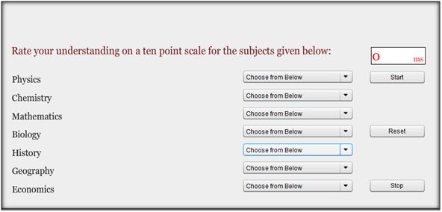

**Interface-2**

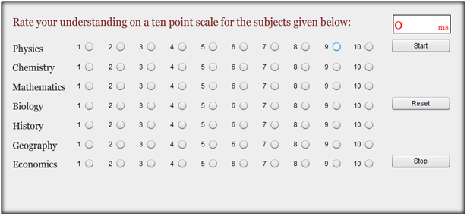

2.    Interface-1 has list-boxes and Interface-2 has radio-buttons to  input user responses.

3. You  are supposed to use interface-1 and interface-2 to rate your understading of few core subjects.

4.   Before you start recording your responses on interface-1 press **“Start”** button to start recording of time.

5.    Then give your responses for each subject using interface-1 (list boxes).

6.     After you finish giving responses for all subjects press **“Stop”** button to stop recording of time.

7.  Once again please note: Press "**Start**" and "**Stop**" buttons to record your time.

8.     Repeat the same procedure from 4 to 6 for interface-2 ( radio buttons ) .

9.     Reset the timer if you wish to repeat the experimentation again.

 To proceed  further  click on the **SIMULATOR** tab on the top or to exit this experiment  click on **HOME**  on the top.

[**Back to HCI Lab Home Page**](http://iitg.vlab.co.in/?sub=72&brch=170)

1.   Can you see two user interfaces below?  Interface-1  has  list-boxes  while  interface-2  has  radio-buttons.

2.    You are  supposed  to  record  your  reponses  using  interface-1  and  then  interface-2.

3.  Before you start recording your responses on interface 1 press **“Start”** button to start recording time.

4.     Then record your responses for each subject using interface 1 (list-boxes).

5.     After you finish giving responses for all subjects press **“Stop”** button to stop recording of time.

6.     Repeat the same procedure from 3 to 5 for interface 2 ( radio-buttons ) .

7.     Reset the timer if you wish  to repeat the experimentation again.

8.  After  performing  the  experiment read  the  **discussion at  the end.**

http://iitg.vlab.co.in/fckeditor/editor/images/spacer.gif

**Discussion :**

Why is there a difference in the task completion time? Is it because of  difference in interaction elements  chosen and  their layout? Is there a cognitive / perceptual factor contributing to task completion time?

An interaction task is always guided by the user goals, interface operators and  alternative methods available on interface for acheiving those goals. In this respect the above two interfaces can be analysed  using GOMS model. Task analysis using KLM-GOMS model for above interfaces can predict the task completion time before hand. Thus the time and cost for user-testing is reduced.

You are  therefore adviced to build  a GOMS  model  for  the  above  task  for both  interfaces  and  compare the predictated  time  with  the actual  time  taken for the task.

 To proceed  further  click on the **QUIZ** tab on the top or to exit this experiment  click on **HOME**  on the top.

[**Back to HCI Lab Home Page**](http://iitg.vlab.co.in/?sub=72&brch=170)

1.     If someone asks you to explain GOMS model how will you go about doing it with examples.

2.     How can GOMS model be used to evaluate user interface designs?

3.     What are different extensions to GOMS model?

To proceed  further  click on the **ASSIGNMENT** tab on the top or to exit this experiment  click on **HOME**  on the top.

[**Back to HCI Lab Home Page**](http://iitg.vlab.co.in/?sub=72&brch=170)

1.    Identify a short word processing task to be accomplished using Microsoft Word. Also identify alternate methods of achieving same task in Word. Draw the GOMS task structure model for both methods and use KLM to predict the task completion times. Compare the two methods on the basis of task completion time. Now redesign the interaction and/or interface and try to reduce the task completion time by effectively utilizing KLM model.

2.   As part-B of the above assignment measure the actual time a user needs to accomplish these tasks while working on a computer screen in your lab. Do your measurements tally with your predictions of  Part A? If no why not?

3.    Consider a drawing task of sketching a square 10cm x 10cm and filling it with blue color. Draw and record time taken to perform this task using any two drawing softwares such as - “Paint”, “Photoshop” etc.Compare the task times between the two softwares. Can you relate this to the GOMS model?

 To proceed  further  click on the **REFERENCE** tab on the top or to exit this experiment  click on **HOME**  on the top.

[**Back to HCI Lab Home Page**](http://iitg.vlab.co.in/?sub=72&brch=170)

**URLs**

( as on 26 January 2012 )

http://www.eecs.umich.edu/~kieras/goms.html

http://en.wikipedia.org/wiki/GOMS

http://www.usabilityfirst.com/usability-methods/hci-design-approaches/

http://www.cs.umd.edu/class/fall2002/cmsc838s/tichi/printer/goms.html

http://tip.psychology.org/card.html

http://www.learning-theories.com/goms-model-card-moran-and-newell.html

http://ei.cs.vt.edu/~cs5724/g2/index.html

**Article**

John, B. E., & Kieras, D. E. (1996). *Using GOMS for user interface design and evaluation: Which technique?* ACM Transactions on Computer-Human Interaction**,** 3, 4, 287-319.

   To give feedback  for this experiment click on the **FEEDBACK** tab on the top or to exit this experiment click on **HOME**  on the top.